Challenge 1:

let myage: Int = 25

var dog: Int = 1

dog += 1

print(dog) #2

Challenge 2:

var age: Int = 16

print(age)

age = 30

print(age) #16 30

challenge 3:

let x: Int = 46

let y: Int = 10

let answer1: Int = (x\*100) + y

let answer2: Int = (x\*100) + (y\*100)

let answer3: Int = (x\*100) + (y/10)

print (answer1, answer2, answer3) #4610 5600 4601

challenge 4:

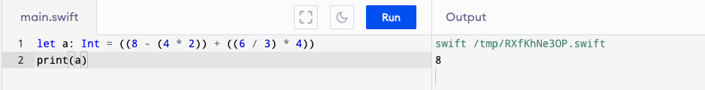

Challenge 5:

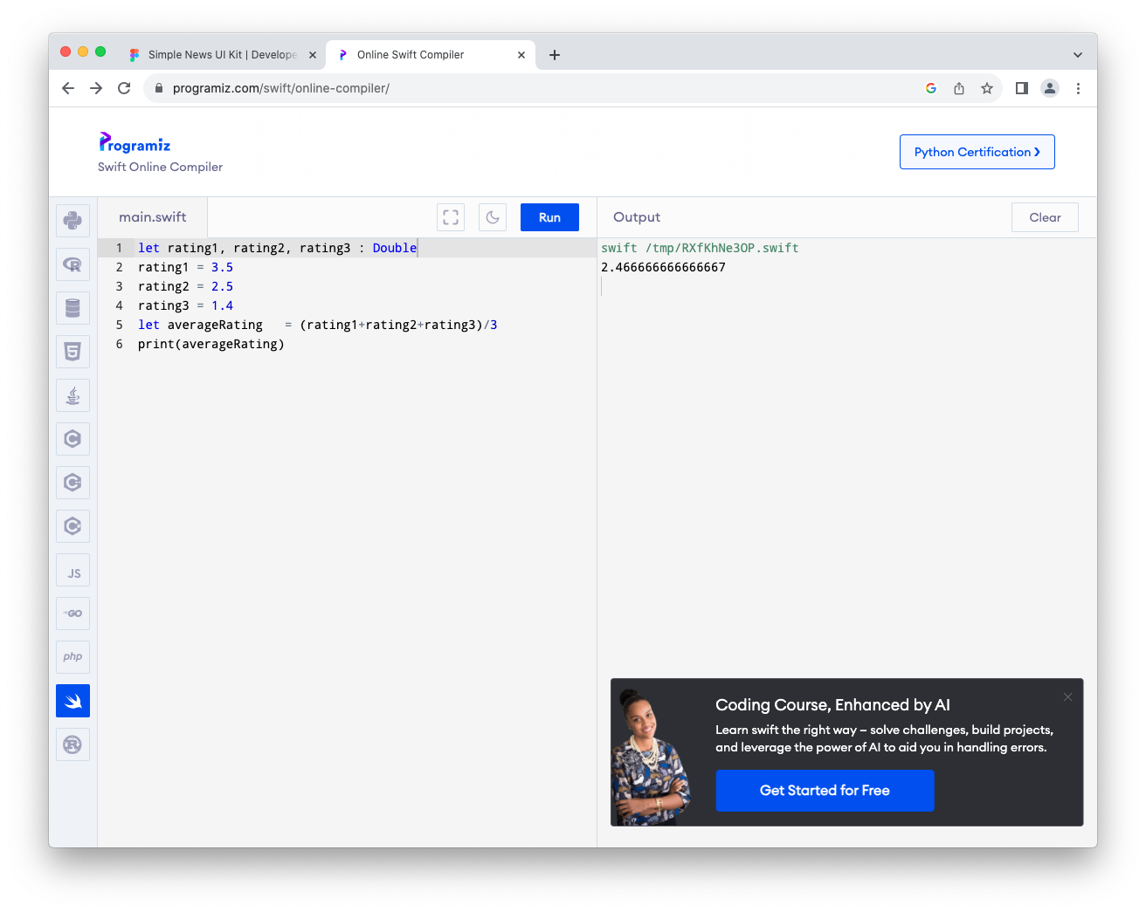

Challenge 6:

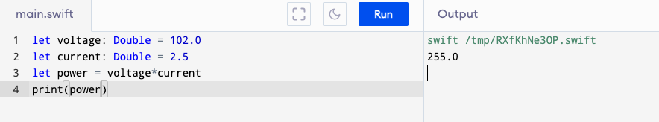

Challenge 7

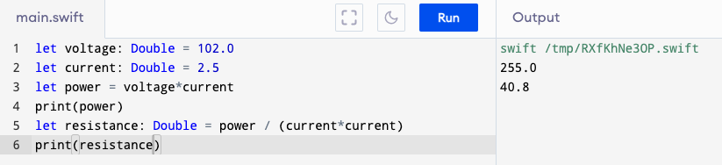

Challenge 8